Sleepify

Design Report

Jeremy Chan, Tsz Ho Ho, Dominic Kwok, Ho Shun Lo, Nathalie Wong

Department of Electrical and Electronic Engineering, Imperial College London, SW7 2AZ  
Email: {jc4913, thh13, cyk113, hsl113, nw813}@ic.ac.uk

*Abstract*—

# Introduction

# Hypothesis

This project aims to provide a better sleeping experience overall from having the room temperature automatically adjust to sleeping schedules and information from a myriad of sensors from a tracking device. This project also advises the user about the best times to go to bed from calendar integration, reducing the effects of jet-lag where possible. The user will benefit from our project according to the following hypotheses:

1. Better sleep quality can be achieved by sleeping in an ideal sleeping temperature, thereby preventing situations where the user cannot fall asleep because the environment is too cold or hot.
2. The feeling of grogginess can be reduced when waking up by setting the alarm to go off when the user is not in deep sleep.
3. The effects of jet-lag can be minimized by gradually adjusting to the destination time zone by modifying sleeping times, before and during the trip [1].

# Motivation and Background

### Sleep quality and its relation to health

Addstages of sleep

jetlag

### How machine learning helps

# Related Work

There are many sleep trackers on the market that use a variety of ways to track sleep quality. Software implementations such as the highly rated Sleep Cycle app [2] for iOS and Android use the accelerometer found in smartphones to track body movement throughout the sleep cycle. Using this data, Sleep Cycle wakes the user up during the lightest sleep phase, preventing the feeling of tiredness in the morning. In addition to the accelerometer, Sleep as Android [3] records audio through he microphone to detect snoring, speech, and ambient noise. This can be played back to the user the following morning, and can be a good indicator of sleep disturbances and stress [4].

## Background Research

# System Design

## Hardware

### Sensors

## Software

-block diagram-

### Machine Learning

### Web Interface

### Mobile Application

The mobile application will serve as the bridge between the cloud processing and the sensors, as well as the central hub on which users can add feedback about their sleep sessions.

Connecting to the band over Bluetooth, the app will collect all the raw data from the band as it records overnight, and send it to the web server. As the Microsoft Band 2’s sensors have different sampling frequencies [5], some pre-processing has to be done on the application to avoid sending huge amounts of data to the web server. To put this into perspective, the accelerometer recording its values at 30Hz generates a 30MB log file in just 6 hours of sleep. Not only is the data sparse (lots of repeating values), uploading a 30MB log file to the server means the solution is not desirable in its scalability for many users.

-add some parametsr on which sensor eneds what, mean, median, etc-

A working prototype that connects, collects, and aggregates data from the Microsoft Band 2 has already been created (Figure 1).

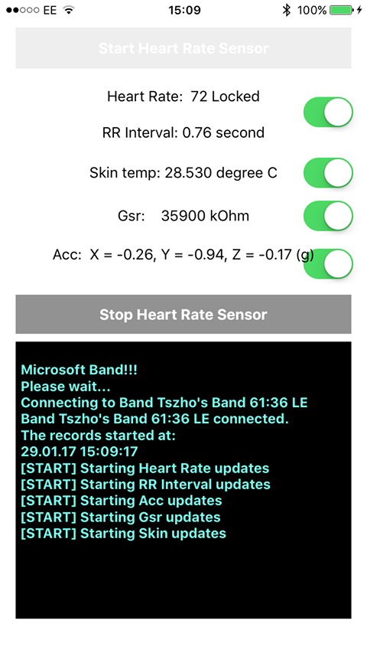

Figure 1: Prototype sensor data collection app

Apart from sensor data logging, the app is also responsible for getting feedback from the user. During the morning, the app will notify the user to rate his sleep last night by the means of a short survey. Some preliminary questions include how the user felt he slept, how hot/cold the user felt the room was, and how many times the user woke up (either naturally, so to use the bathroom, or unnaturally, because of external noise). Together with the data from the sensors, the survey will be sent to the cloud for further processing and statistics.

The mobile application is also responsible for receiving the data from the cloud after processing. As the machine learning algorithms come up with a suitable temperature value for the room, the app will connect to the home’s smart heating solutions to change the thermostat to the desired temperature. The current plan is to support Google’s Nest thermostats using their Nest API [6] as it comes with ample documentation and support (Figure 2).

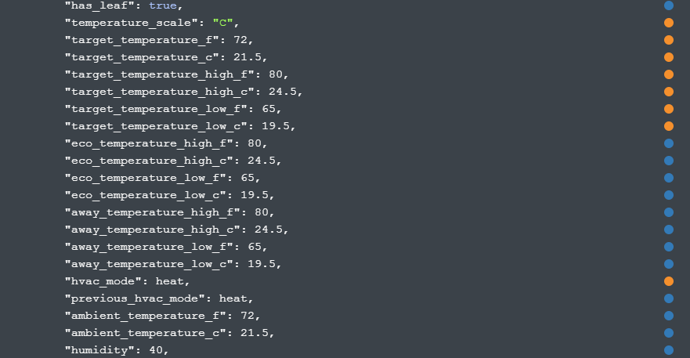

Figure 2: Nest API

Other features currently planned include the replication of the smart alarm clock feature, which wakes the user up during the lightest period of sleep. Additionally, calendar integration with the web interface is also planned, to allow for notifications to sleep earlier/later depending on the time zone of the next few day’s events. An intuitive GUI has also been drafted up (Figure 3).

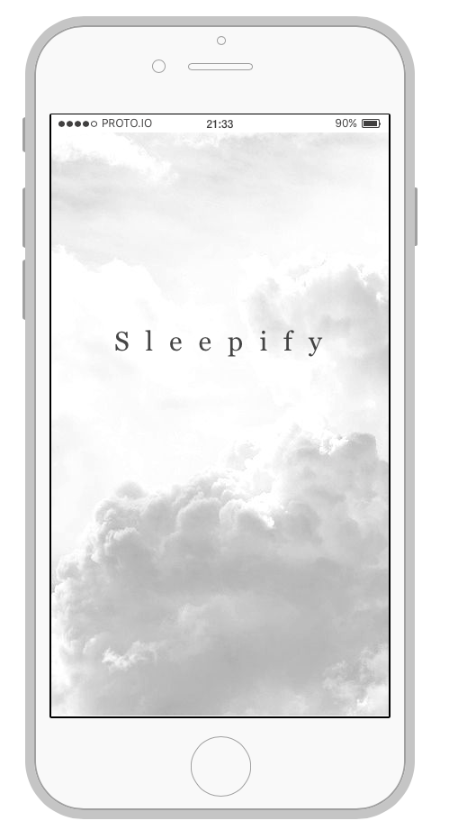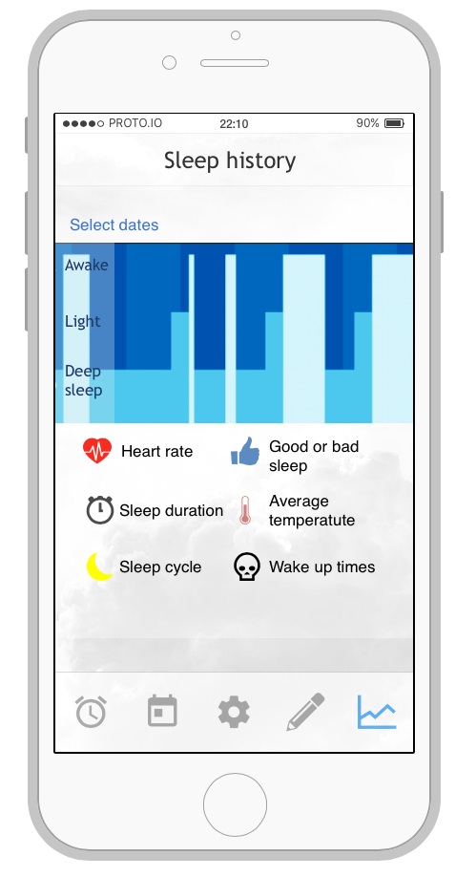

Figure 3: GUI Mock-up

# Evaluation Criteria

# Conclusion

asdf

# References

[1] J. Waterhouse, T. Reilly, G. Atkinson, and B. Edwards, ‘Jet lag: trends and coping strategies’, *The Lancet*, vol. 369, no. 9567, pp. 1117–1129, 2007.

[2] ‘Sleep Cycle alarm clock on the App Store’, *App Store*. [Online]. Available: https://itunes.apple.com/gb/app/sleep-cycle-alarm-clock/id320606217?mt=8. [Accessed: 01-Feb-2017].

[3] U. Team, *Sleep as Android Unlock*. Urbandroid Team, 2016.

[4] M. M. Ohayon and C. M. Shapiro, ‘Sleep disturbances and psychiatric disorders associated with posttraumatic stress disorder in the general population’, *Compr. Psychiatry*, vol. 41, no. 6, pp. 469–478, Nov. 2000.

[5] A. Alvi and T. Andrews, ‘Microsoft Band: Developing for Microsoft Band and Microsoft Health’.

[6] ‘Nest API Reference’. [Online]. Available: https://developers.nest.com/documentation/api-reference. [Accessed: 01-Feb-2017].